

***(An Autonomous Institute)***

# Walchand College Of Engineering, Sangli

Department of Information Technology

A Project Report On

# MESSMANAGEMENT

## Team

Shailendra Mahadule 226200032262000322620003

Aaditya Patil 21610005

Rakesh Dharne 21610022

Under the guidance of

### Prof. D. B. Kulkarni

Information Technology Dept, WCE, Sangli. Year: 2022-23



**Walchand College Of Engineering, Sangli**

***(An Autonomous Institute)***

Department of Information Technology

**CERTIFICATE**

This is to certify that the Project Report entitled,

**Mess Management** Submitted by

|  |  |
| --- | --- |
| Shailendra Mahadule | 22620003 22620 |
| Aaditya Patil | 21610005 |
| Rakesh Dharne | 21610022 |

to Walchand College of Engineering, Sangli, India, is a record of bonafide Project work carried out by them under my supervision and guidance and is worthy of consideration for the award of the degree of Bachelor of Technology in

Information Technology of the Institute.

|  |  |
| --- | --- |
| **Prof. D. B. Kulkarni** | **Dr. R. R. Rathod** |
| Guide Information Technology Dept, | Head Of Department Information Technology Dept, |
| WCE, Sangli. | WCE, Sangli |

# Acknowledgment

We feel immense pleasure in submitting this project report entitled **Mess Management.**

We are thankful to our guide **Prof. D. B. Kulkarni** and our Head of Department **Dr. R. R. Rathod** for their valuable guidance and kind help during the completion of this project. We truly appreciate and value their esteemed guidance and encouragement from the beginning to the end of this project.

We would also like to thank **Sachin Mess** and **Yes Sir Mess** for providing us valuable insight regarding the difficulties faced with the current functioning of the mess. This has helped us to devise a more convenient mess management system.

Lastly, we would like to thank all the team members who have made this project possible through their teamwork and dedication.

## Declaration

We hereby declare that the work presented in this project report titled **Mess Management** submitted by us in the partial fulfillment of the requirement of the award of the degree of **Bachelor of Technology (B. Tech)** Submitted in the **Department of Information Technology, Walchand College of Engineering, Sangli**, is an authentic record of our project work carried out under the guidance of **Prof. D. B. Kulkarni**

### Team

Shailendra Mahadule 226200032262000322620003

Aaditya Patil 21610005

Rakesh Dharne 21610022

Date: - -2023

Place: Sangli (Signatures)

#### ABSTRACT

The idea is to develop an android application that will make an easy management of mess with a digital approach. In today’s world where every process is getting digitized and getting more effective thus, we planned to digitize the mess management system of the mess .We tried to modify the current traditional pen paper process of the mess and replace it with a completely digital approach.

The Mess Management System is a mobile application designed to provide convenience and efficiency to its users in managing their mess expenses, schedules, and communication with subscribers. The app features a daily expense tracker, calendar, data table, subscriber photos, expiry dates, alert notifications, and messaging services. With this app, users can easily monitor their daily expenses and budget, organize their mess schedule, and communicate with their subscribers effectively. The subscriber photo and expiry date features enable the users to have a better understanding of their subscribers, while the alert notifications ensure that they never miss any important dates. Overall, the Mess Management System is an essential tool for anyone who wants to efficiently manage their mess expenses and communication with subscribers.

# Table Of Contents

|  |  |  |
| --- | --- | --- |
| Sr No. |  | Page No. |
| 1 | **Introduction** |  |
|  | **1.1 Overview and Problem Statement** |  |
| 2 | **Project Objectives** |  |
| 3 | **Proposed Method** |  |
|  | 3.1 **Problem Definition** |  |
|  | 3.2 **Proposed Idea/System** |  |
|  | 3.3 **System Architecture** |  |
|  | 3.4 **System Analysis and Design** |  |
|  | 3.4.1 **Requirement Specification** |  |
|  | 3.4.2 **Flowcharts and UML** |  |
| 4 | **Performance Study** |  |
|  | 4.1 **Implementation/Simulation Environment** |  |
|  | 4.2 **Results** |  |
| 5 | **Future Scope** |  |
| 6 | **Project Timeline** |  |
| 7 | **Conclusion** |  |
| 8 | **References** |  |

## 1. Introduction

In Mess Management System app it will be solving the problems of the mess owner which have to keep the record of the registered customers who comes in mess and their task of maintaining record gets hectic by using pen and paper so to overcome this problem Mess Management app will help the owner to make the record of the customers and also it will calculate the due dates and paying of the customers and will notify the customer prior regarding their paying.

### 1.1 Overview and Problem Statement

Problem statement: Mess management refers to the process of managing food services in institutions such as hostels, universities. Mess management faces several challenges such as managing costs, accommodating diverse dietary requirements, and ensuring timely delivery of meals. Therefore, there is a need for an effective mess management system that can address these challenges and ensure a smooth and satisfactory food service experience for all customers.

### 2. Project Objectives

* Smooth functioning of mess
* Effective maintenance of Record
* To overcome the shortcoming which were experienced by mess owner
* Integrating a notification system for mess owner
* Expense Tracker
* Multi-Language

### 3. Proposed Method

**Problem Definition:**

To design and implement the **Mess Management** mobile application.

#### 3.2 Problem Faced

* Registration of customers and management of records is done by a pen-paper system.
* Difficult to sort or organize data in any order.
* The due date for each person must be calculated manually.
* Difficult to remember when the number of customers increases.

### 3.1Proposed Idea/System

* The due date for each subscription will be calculated automatically and displayed.
* Allow the mess user to sort data by fields such as date of registration and subscription expiry date.
* Display the list of members whose subscription plan is expiring on the current day, as well as the members whose plans have already expired.

#### 3.2 System Architecture

This is the architecture for our project. Project work is carried out according to this model.

#### 3.3 System Analysis and Design

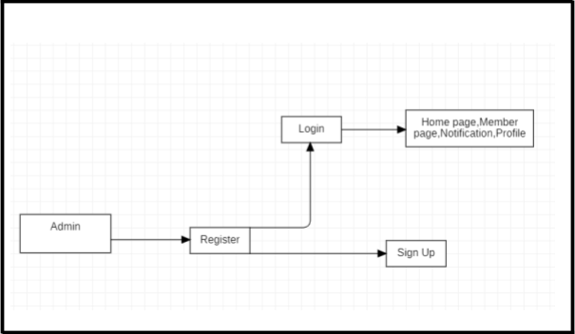

**Fig no. 1**

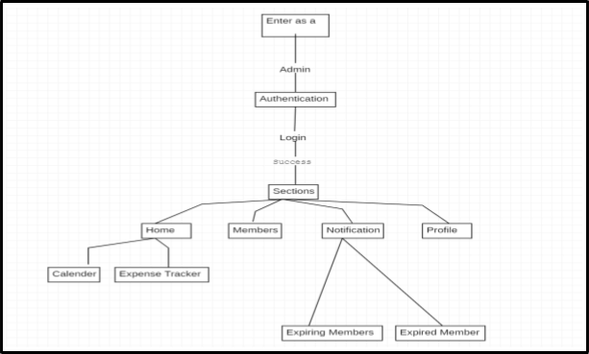

**Fig no.**

##### 3.3.1 Requirement Specification

It is very important to get the users of the application fully involved such that they have a better user experience.

The system is expected to be:

1. User friendly.
2. Provide quick notifications.
3. Available in different Languages.
4. Data Sorting.
5. Available for both android and ios users.

**Hardware Requirements:**

● Operating system : Android or IOS

**3.3.2 Flowcharts / DFDs / UML**

#### ● FLOWCHART

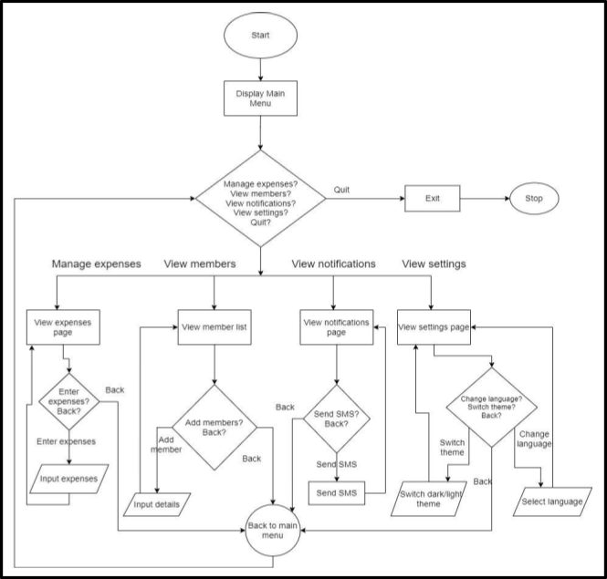

**Fig no.4**

**● Class Diagram:**

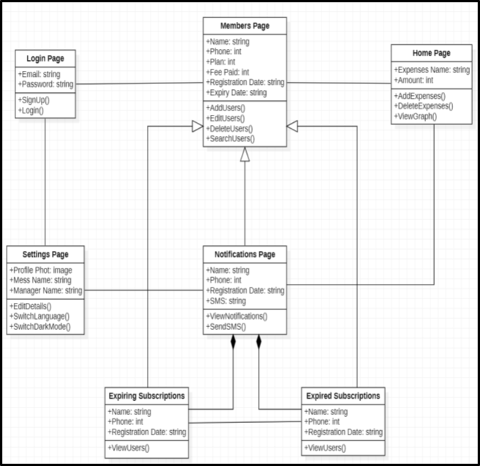

**Fig no.5**

### Performance Study

#### 4.1 Implementation/Simulation

**Environment User UI:**

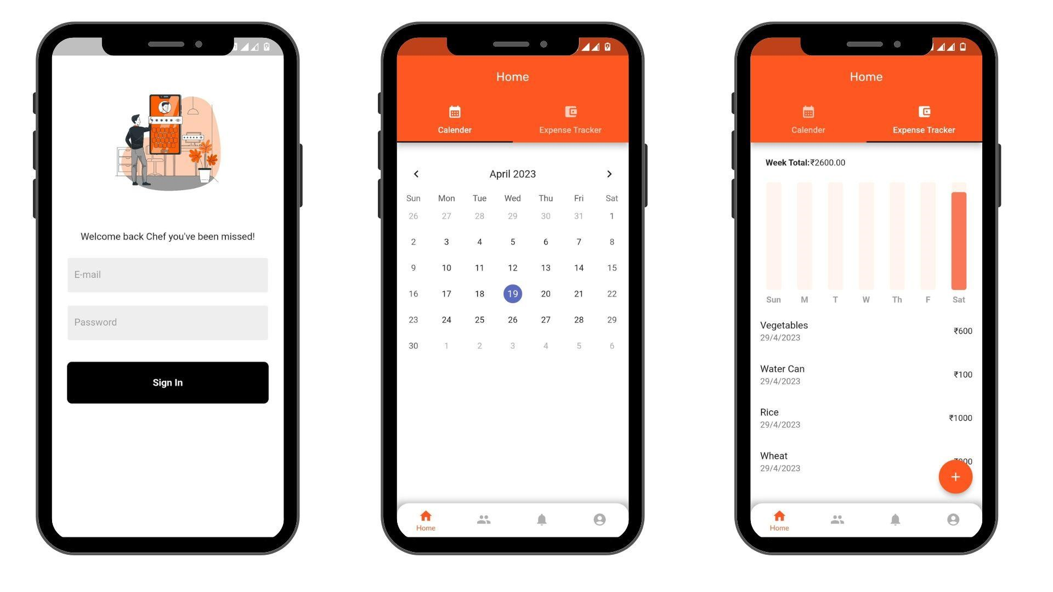

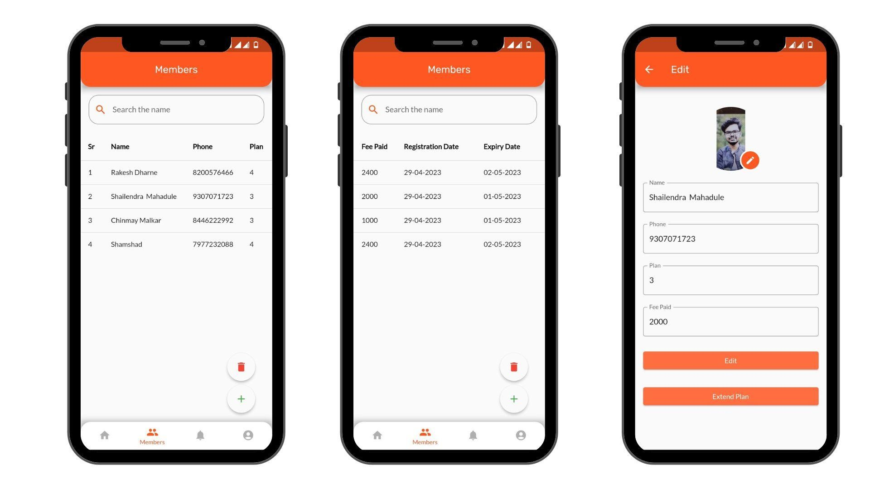

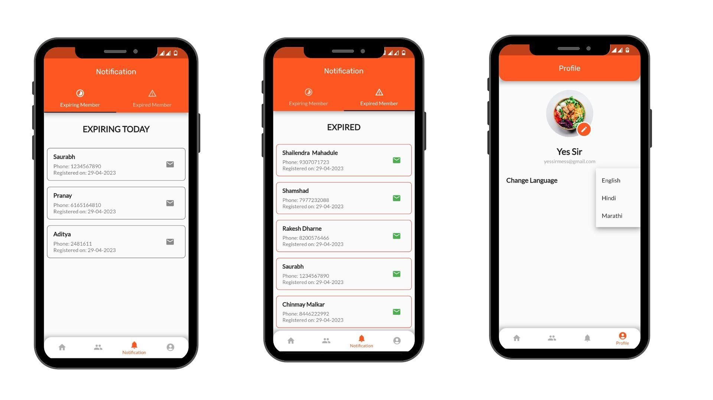

### 4.2Results

The system has been designed according to the intended objectives. The application has been delivered based on the earlier proposed idea, a user-friendly mobile application, **Mess Management System**

## 5. Future Scope

The future of mess management apps for mess owners holds great potential for streamlining and improving the management of mess facilities. By incorporating advanced features and technologies, these apps will enhance efficiency, organization, and communication for mess owners.An overview of the future scope for a mess owner's mess management app that includes an expense tracker, calendar, member pages, language change feature, and specific functionalities tailored for the needs of mess owners:

Expense Tracker:

The app will offer a comprehensive expense tracker that enables mess owners to monitor and manage expenses related to groceries, utilities, maintenance, and other operational costs. It will provide real-time insights into spending patterns, assist in budgeting and financial planning.

Member Pages:

The app will include dedicated member pages that contain essential details about each subscriber, such as their name, mobile number, registration date, and expiry date of their mess subscription. Mess owners can easily access and update subscriber information, view subscription statuses, and manage membership renewals and expirations.

Expiring and Expired Member Pages:

To streamline subscriber management, the app will have separate sections for expiring and expired members. Mess owners will receive notifications and reminders when a member's subscription is approaching expiry or has already expired. This feature will enable mess owners to take necessary actions promptly, such as communicating with members and renewing subscriptions.

Language Change:

The app will support multiple languages, including Marathi and Hindi, allowing mess owners to switch between languages based on their preferences. This language change feature will enhance usability and convenience for mess owners who are more comfortable using regional languages.

By integrating these features into a dedicated mess owner's mess management app, the future scope focuses on empowering mess owners to effectively manage their mess facilities. The app will streamline administrative tasks, facilitate communication with subscribers, ensure efficient operations, and ultimately enhance the overall mess management experience.

## 6. Project Timeline

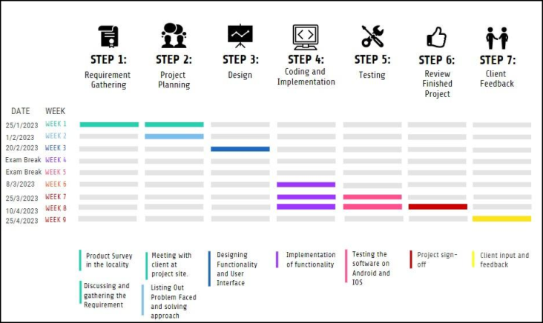

### 7.Conclusions

Mess Management app is a versatile and efficient solution for individuals and organizations seeking a comprehensive food management tool. With its expense tracking feature, subscribers can easily monitor their spending and stay within their budget. The sorting table provides a convenient way to manage and track subscribers' meal preferences and requirements, ensuring that everyone is accommodated. The alert notification feature helps to keep users informed of important events and deadlines, reducing the chances of missing any crucial information. Moreover, the app's availability in multiple languages and support for both Android and iOS devices make it accessible to a wider audience. Overall, the Mess Management app is a powerful and customizable tool that can help simplify meal management processes and improve overall efficiency.

The system has been designed according to the proposed objectives. Nearly all of the objectives are implemented. The system has been delivered.

**8.References:**

**1.**[**https://www.ijert.org/research/mess-management-system-implementatio n-IJERTCONV3IS24003.pdf**](https://www.ijert.org/research/mess-management-system-implementation-IJERTCONV3IS24003.pdf)

**2.**[**https://businessideasmarathi.in/tiffin-service-business-information-mara thi**](https://businessideasmarathi.in/tiffin-service-business-information-marathi)

### OUR TEAM

